Name: Ayan Sadhukhan

Regd No: 19BEC1448

*Question:*

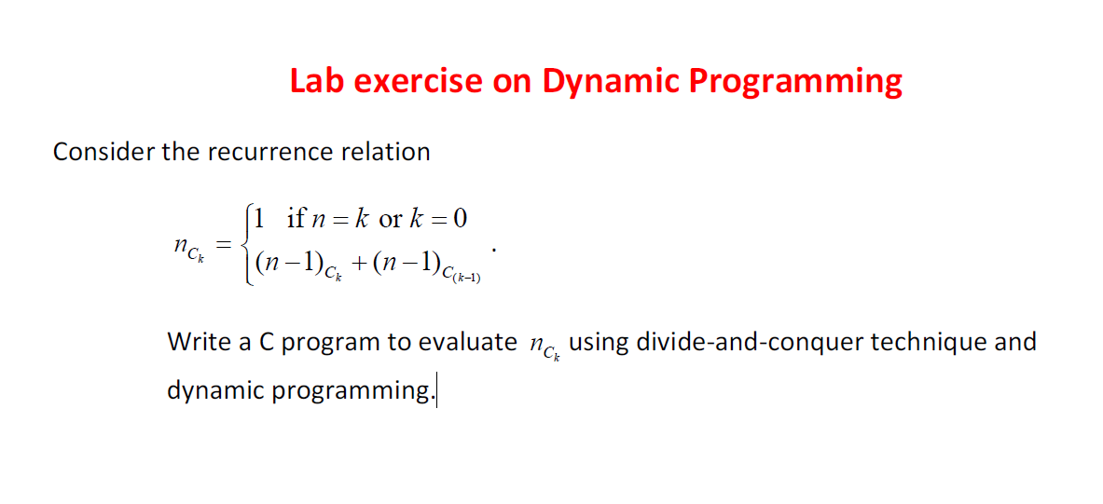

*Code:*

#include<stdio.h>  
#include<conio.h>  
int save[100][100];  
int coef(int n, int k)  
{  
if(save[n][k]>0)  
       return save[n][k];  
    if(n==k or k==0) return 1;  
    else  
          save[n][k]= coef(n-1,k)+coef(n-1,k-1);  
     printf(" exit  n= %d    save[%d]= %d\n",n,n,save[n][k]);  
        return save[n][k];  
}  
main()  
{  
int n,k,m,i,j;  
printf("Enter the values for n and k");  
scanf("%d %d",&n,&k);  
for(i=0;i<n;i++)  
{  
  for(j=0;j<n;j++)  
     save[i][j]=0;  
}  
m=coef(n,k);  
printf("\n Binary Coeff(%d) = %d",n,m);  
  
}

*Output:*

